Test Review: Look over your notes on Classification, biomes, succession, minimizing human impacts
Skills –
- Graphing –
  - Make sure your points go through the right line.
  - Do not extend the line unless they tell you to
a) 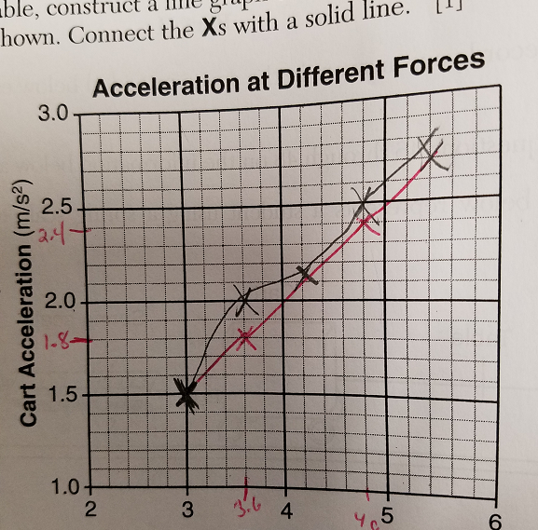 b) 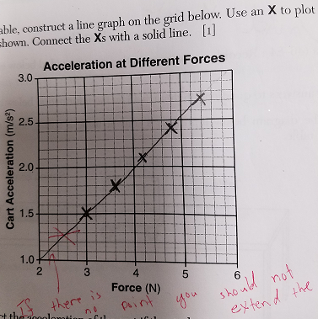

- Experimental design
  - Independent variable = what is the one difference between the groups
  - Dependent variable = Data = what did they have to measure in the experiment
  - Control group = No Independent variable or normal amounts of the independent variable
  - Determining relationships between 2 things
    - Example of relationships between 2 things on a graph
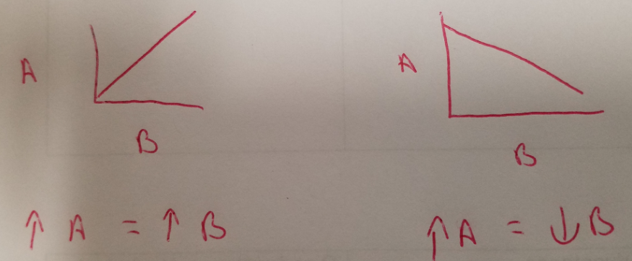

- Classification
  - D-K-P-C-O-F-G-S
  - Domain – kingdom – phylum – class – order – family – genus – species
  - Most general --------------------------------------------------------least general
  - Least specific --------------------------------------------------------most specific
  - Least closely related ----------------------------------------------most closely related
  - Ex: organisms in the same genus are more closely related than organisms in the same kingdom
  - Remember fungi = decomposers

- Contour lines show the elevation of land (how high is the land above sea level)
  - Example:
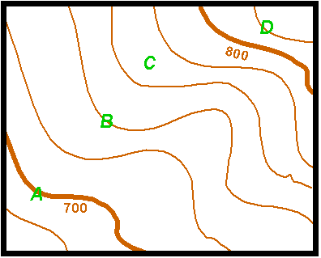
Contour interval = 20 feet

Elevation of B = ______________
Elevation of C = ______________

  - Answer: B is 740 feet and C is a number between 760 and 780 so 765 feet would be a good answer

