Experimental Design Notes for 8th Grade Science Name: _________________________
Observations vs Inferences
Observations = _________________________________________________________
Inferences = ___________________________________________________________
Examples:
Observations:
- I hear people screaming
- I smell cotton candy and popcorn
- I see a lot of people
Inference:
- ________________________________________________________________

Look at the 2 sets of animal tracks
- List 3 observations about the tracks

  - Make an inference based on the first set of drawings.

- Look at the 2 set of footprints and make 3 observations

  - Make a new inference based on the 2nd set of footprints

- Make 3 observations based on the 3 sets of footprints

  - Final inference based on the 3 sets of footprints.

Practice: Write an O if the statement is an observation and n I if it is an inference
- _____ The container is filled to the 350ml mark with water
- _____ The Sun rose at 6:45 this morning
- _____ Dinosaurs died out when they could not adapt to changing climate
- _____ When the power is turned on, the game lights up and plays a song
- _____ The caterpillar did not eat the moth because it is not a carnivore.

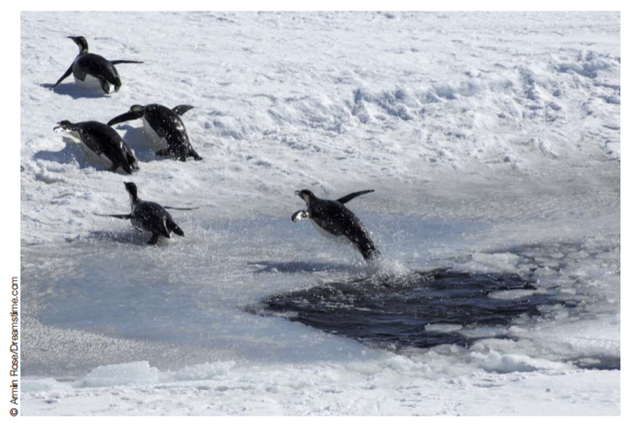
- Make 2 observations and 2 inferences about the picture shown above
  - Observations: ________________________________________________________________________

________________________________________________________________________
  - Inferences: ________________________________________________________________________

________________________________________________________________________

Tools for making observations
- Rulers
- Graduated cylinders
- Triple beam balance
- Microscopes

Using Rulers to measure length
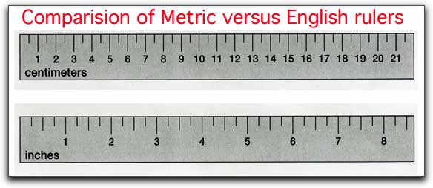
Centimeters = ___________
Inches = ____________ = ___________
How big is it?
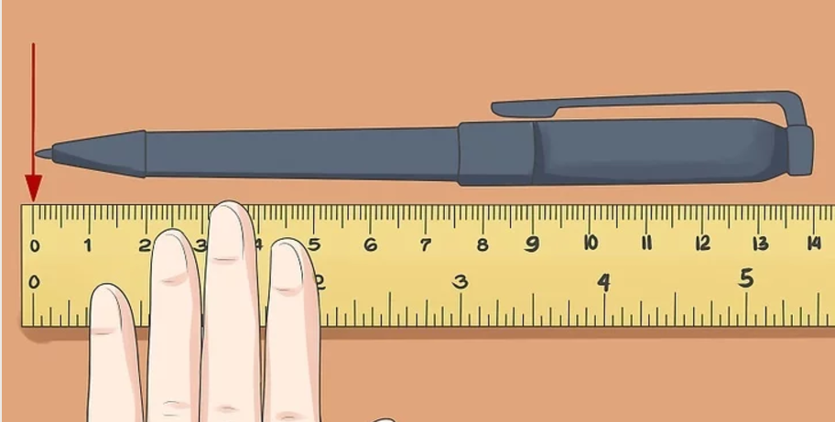 _____________
How big is it?
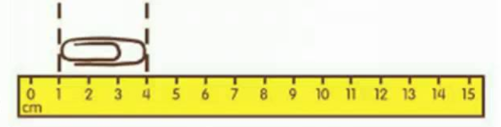 __________

How many mm in a cm? ______________
__________ mm

How big is the spotted salamander (from snout to vent)?
English units
__________inches
__________in
__________ “
Metric units
__________centimeters
__________cm
__________millimeters
__________mm

Measuring practice questions
- What is the approximate length of the earthworm shown in the diagram below?
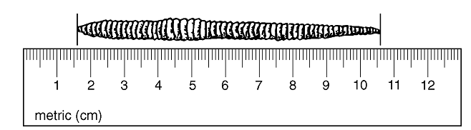

  - 90 mm
  - 9 mm
  - 10.6 cm
  - 106 cm

- A diagram of the actual size of a peppered moth wingspan is shown below.
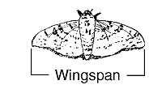
An estimated length of the wingspan could be

  - 3 centimeters
  - 3 grams
  - 3 milliliters
  - 3 kilometers

- The diagram below represents the measurement of a flatworm.
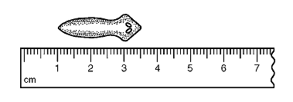
What is the approximate length of the specimen in millimeters?

  - 25mm
  - 30mm
  - 35mm
  - 40mm

- How tall is the moss plant in millimeters?
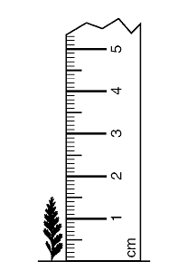

  - 15 mm
  - 1.5 mm
  - 150 mm
  - 1,500 mm

- A student measured a tadpole using a metric ruler, as represented in the diagram below.
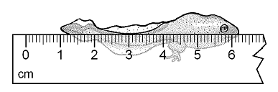
What is the approximate length of the tadpole in centimeters (cm)?
  - 5.2 cm
  - 52 cm
  - 6.2 cm
  - 6.0 cm

Experimental design vocabulary
Hypothesis | A statement explaining an observation
 | The thing you are testing (only difference between the groups)
 | Group that does not get the independent variable (needed for comparison)
 | = Data = thing being measured in an experiment
Statement explaining what you think will happen if you do an experiment
(ex: If I add ___ then ___ will happen

Practice
For each experiment state the independent variable and describe the control group
- You want to know if caffeine changes your heart rate
  - Title: The effect of _________________________ on _____________________
  - Independent variable = ________________________________________
  - Control group = ______________________________________________
  - Dependent variable = ________________________________________
  - Hypothesis = ________________________________________________________________________________________________________________________________________________

- You want to know how much bleach it takes to kill bacteria
  - Title: The effect of _________________________ on _____________________
  - Independent variable = ________________________________________
  - Control group = ______________________________________________
  - Dependent variable = ________________________________________
  - Hypothesis = ________________________________________________________________________________________________________________________________________________
- You want to know if blood pressure is affected by height
  - Title: The effect of _________________________ on _____________________
  - Independent variable = ________________________________________
  - Control group = ______________________________________________
  - Dependent variable = ________________________________________
  - Hypothesis = ________________________________________________________________________________________________________________________________________________
- You want to know if pH has an effect on seed germination
  - Title: The effect of _________________________ on _____________________
  - Independent variable = ________________________________________
  - Control group = ______________________________________________
  - Dependent variable = ________________________________________
  - Hypothesis = ________________________________________________________________________________________________________________________________________________

Things that make experiments better (more reliable) (more accurate)
- Only test one variable at a time (everything must be the same except that one thing you are testing)
- Include a control group (no or normal amounts of thing being tested) to use for comparison
- REPEAT, REPEAT, REPEAT with large sample sizes same results
Practice exam questions
- An experiment is described below.

A large field at the base of a mountain becomes flooded when heavy rains in the mountains cause a stream to overflow. Each time the flooding occurs, more soil washes away.
The owners of the land want to perform an experiment to see if different types of plants could help reduce the soil erosion. They choose five areas of ground that are the same size, the same distance from the stream, have the same slope and the same kind of soil, and receive the same amount of sunlight. The type of plant planted in each area is different for each of the five areas. Measurements of soil erosion will be made each time flooding occurs. The results will be compared after six months.

Which hypothesis is being tested in this experiment?
  - Soil erosion is affected by the strength of the wind
  - Flooded areas have greater soil erosion than areas that are not flooded
  - Some types of plants reduce soil erosion more than others
  - Some types of soil are more easily eroded.

Base your answers to the next 3 answers on the information below and on your knowledge of science.
A student placed three identical plant seedlings in soil in three identical containers and gave each seedling a different amount of water each day. The student measured the height of each seedling every day for four days. The results are shown in the data table below.
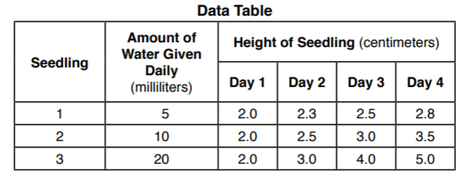
- Identify the dependent (responding) variable in this experiment. ___________________________________________
- Describe the general relationship between the amount of water each seedling received and its height on day 4. ______________________________________________________________________________

______________________________________________________________________________
- The plant seedlings and containers were identical. Identify one additional factor that should be held constant in this experiment. ______________________________________________________________________________

