Alligator Lab My name: ________________________________
Pre Lab: Describe the difference between an inch (“) and a centimeter (cm) (in your description be sure to give an example of a part of your body that is the same size as each)
Inch

Centimeter

Describe a millimeter (mm) and state the number of mm in one cm

Title: The effect of saltwater on alligator growth

Lab partners: ______________________________________________

Independent variable of the experiment = ___________________________________________
Dependent variable = ____________________________________________
Hypothesis: _______________________________________________________________________
Procedures:
- Set up and label 2 bags with your group name and the date
- Fill one with freshwater and label “fresh”
- Fill the other one with salt water and label “salt”
- Record the length of your alligators (from snout to vent) then place one in the freshwater and one in the salt water
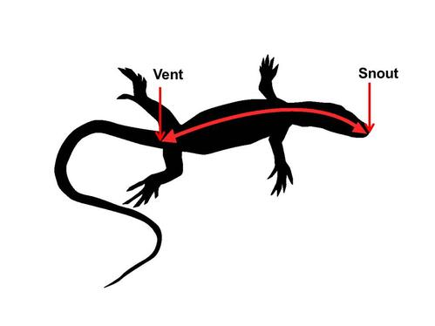
- Record the length of each alligator each day for 2 weeks

Results:
Day | Length of alligator in freshwater  (mm) | Length of alligator in saltwater  (mm)
0
1
2
3
4
5
6
7
8
9
10
11
12
13
14
15

Graph your results:
- On the grid below put an appropriate scale for the growth of your alligators on the y axis.
- On the grid below use an X to plot the growth of the alligator in freshwater for each day shown in the data table. Connect the Xs with a line.
- On the grid below use an O to plot the graph of the alligator in saltwater for each day shown in the data table. Connect the Os with a line.

Alligator Length
Alligator length (mm)
0 1 2 3 4 5 6 7 8 9 10 11 12 13 14 15
Day of Experiment

X = Freshwater
O = Saltwater

Graphing Class Data Using Google Sheets
- Log in to your lakeplacidcsd.net google drive (username = school email, password =)
- Click on the sharable link below
https://docs.google.com/a/lakeplacidcsd.net/spreadsheets/d/16Px2vuMIM_rqxd8ejyrUn06fvHE037ZJQ7TtewAC-SY/edit?usp=sharing
- Open up the Alligator Lab and look at the bottom of the page
- Click on your group number to open up your sheet and put in your data in row 3 of your sheet

